11

al., 2012).

and Climatic Research Unit (Morice et

HadCRUT4 dataset from the Met Ofﬁce

Ofﬁce Hadley Centre, based on the

the 60-year averages. Source: Met

picture for 30-year; and (4th plot)

given date; (3rd plot) the equivalent

for the ten years centred on any

the annual average temperature

annually averaged data; (2nd plot)

average and range of uncertainty for

average) the plots show (top) the

Centre relative to the 1961-90

data from the UK Met Ofﬁce Hadley

for the period 1850-2019 (using the

For the global average temperature

to more easily see long-term trends.

these longer timescales allows one

Calculating a “running average” over

longer records are typically used.

climate change, multi-decadal and

inferences about human-induced

decade to decade. To make reliable

naturally from year to year and from

The climate system varies

Figure .

changes in the atmospheric levels of CO

and other greenhouse gases.

2

Even as CO

is rising steadily in the atmosphere, leading to gradual warming of Earth’s surface, many natural

greenhouse gases and aerosols (airborne particles that can have both warming and cooling effects) from

2

factors are modulating this long-term warming. Large volcanic eruptions increase the number of small

coal-ﬁred power plants and other pollution sources.

particles in the stratosphere. These particles reﬂect sunlight, leading to short-term surface cooling lasting

typically two to three years, followed by a slow recovery. Ocean circulation and mixing vary naturally on many

time scales, causing variations in sea surface temperatures as well as changes in the rate at which heat is

transported to greater depths. For example, the tropical Paciﬁc swings between warm El Niño and cooler La

Niña events on timescales of two to seven years. Scientists study many different types of climate variations,

such as those on decadal and multi-decadal timescales in the Paciﬁc and North Atlantic Oceans. Each

type of variation has its own unique characteristics. These oceanic variations are associated with signiﬁcant

regional and global shifts in temperature and rainfall patterns that are evident in the observations.

Warming from decade to decade can also be affected by human factors such as variations in emissions of

These variations in the temperature trend are clearly evident in the observed temperature record

[Figure ].

Short-term natural climate variations could also affect the long-term human-induced climate

change signal and vice-versa, because climate variations on different space and timescales can interact

with one another. It is partly for this reason that climate change projections are made using climate

models (see infobox, p.20) that can account for many different types of climate variations and their

0°C

interactions. Reliable inferences about human-induced climate change must be made with a longer view,

using records that cover many decades.

0.5°C

Annual average

0°C

−0.5°C

0.5°C

0°C

10-year average

−0.5°C

0.5°C

30-year average

−0.5°C

0.5°C

0°C

60-year average

−0.5°C

1850

1900

1950

2000

Evidence & Causes 2020

understanding that the long-term warming trend is primarily due to human-induced

term variations are mostly due to natural causes, and do not contradict our fundamental

to place, as is expected from our understanding of the climate system. These shorter-

Yes. The observed warming rate has varied from year to year, decade to decade, and place

9

one decade to another?

Does the rate of warming vary from

Q& A n

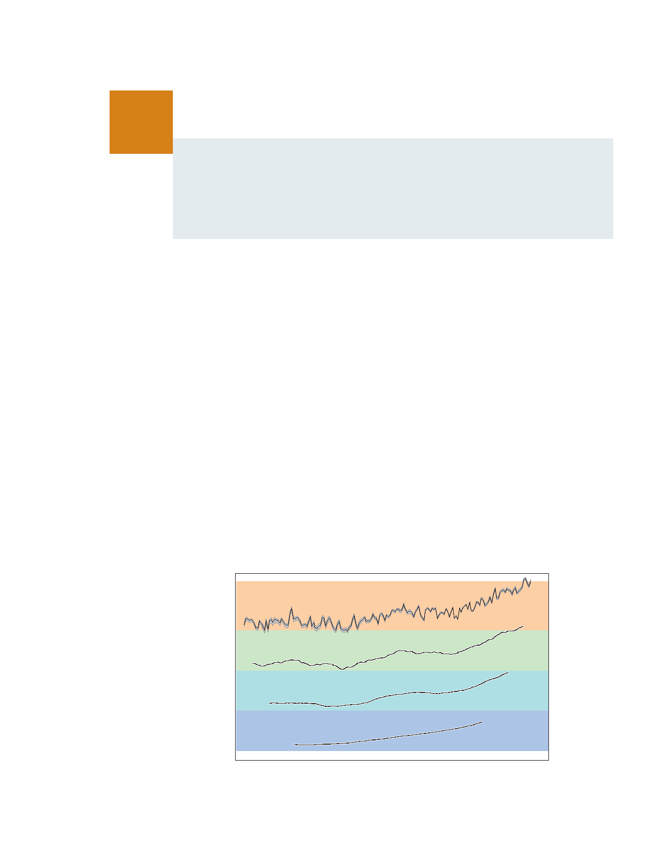

12

Climate Change

warming that will occur from a given amount of CO

. For example, recent studies show that some heat

ice, glaciers and the Greenland ice sheet.

2

comes out of the ocean into the atmosphere during warm El Niño events, and more heat penetrates to

ocean depths in cold La Niñas. Such changes occur repeatedly over timescales of decades and longer. An

example is the major El Niño event in 1997–98 when the globally averaged air temperature soared to the

highest level in the 20th century as the ocean lost heat to the atmosphere, mainly by evaporation.

Even during the slowdown in the rise of average surface temperature, a longer-term warming trend

was still evident (see Figure 4). Over that period, for example, record heatwaves were documented in

Europe (summer 2003), in Russia (summer 2010), in the USA (July 2012), and in Australia (January 2013).

Each of the last four decades was warmer than any previous decade since widespread thermometer

measurements were introduced in the 1850s. The continuing effects of the warming climate are seen in

the increasing trends in ocean heat content and sea level, as well as in the continued melting of Arctic sea

slow the warming seen at the surface and in the atmosphere, but by itself it will not change the long-term

and penetrates only slowly into deep water. A faster rate of heat penetration into the deeper ocean will

More than 90% of the heat added to the Earth system in recent decades has been absorbed by the oceans

from volcanic eruptions).

external inﬂuences on climate (such as particles formed from material lofted high into the atmosphere

temperatures can be rapidly affected by heat uptake elsewhere in the climate system and by changes in

150 years and are also captured by climate models. Because the atmosphere stores very little heat, surface

Decades that are cold or warm compared to the long-term trend are seen in the observations of the past

Decades of slow warming as well as decades of accelerated warming occur naturally in the climate system.

temperature arising from human-induced changes in greenhouse gases.

of Earth’s surface does not invalidate our understanding of long-term changes in global

any preceding year in the instrumental record. A short-term slowdown in the warming

temperatures between 2014 and 2015, with all the years from 2015-2019 warmer than

the 1990s. The limited period of slower warming ended with a dramatic jump to warmer

temperature increases. Despite the slower rate of warming, the 2000s were warmer than

increase in average surface temperature slowed relative to the previous decade of rapid

No. After the very warm year 1998 that followed the strong 1997-98 El Niño, the

climate change is no longer happening?

10

the 2000s to early 2010s mean that

Did the slowdown of warming during

n Q& A

